- VS code Installation completed and “AI CLASS” Folder Created
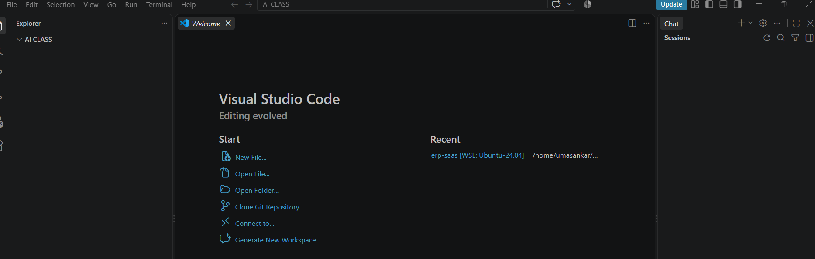

- Python installed successfully
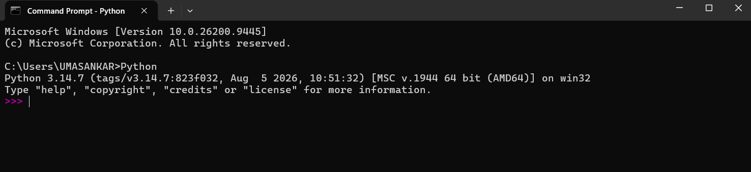

- GitHub Sign in
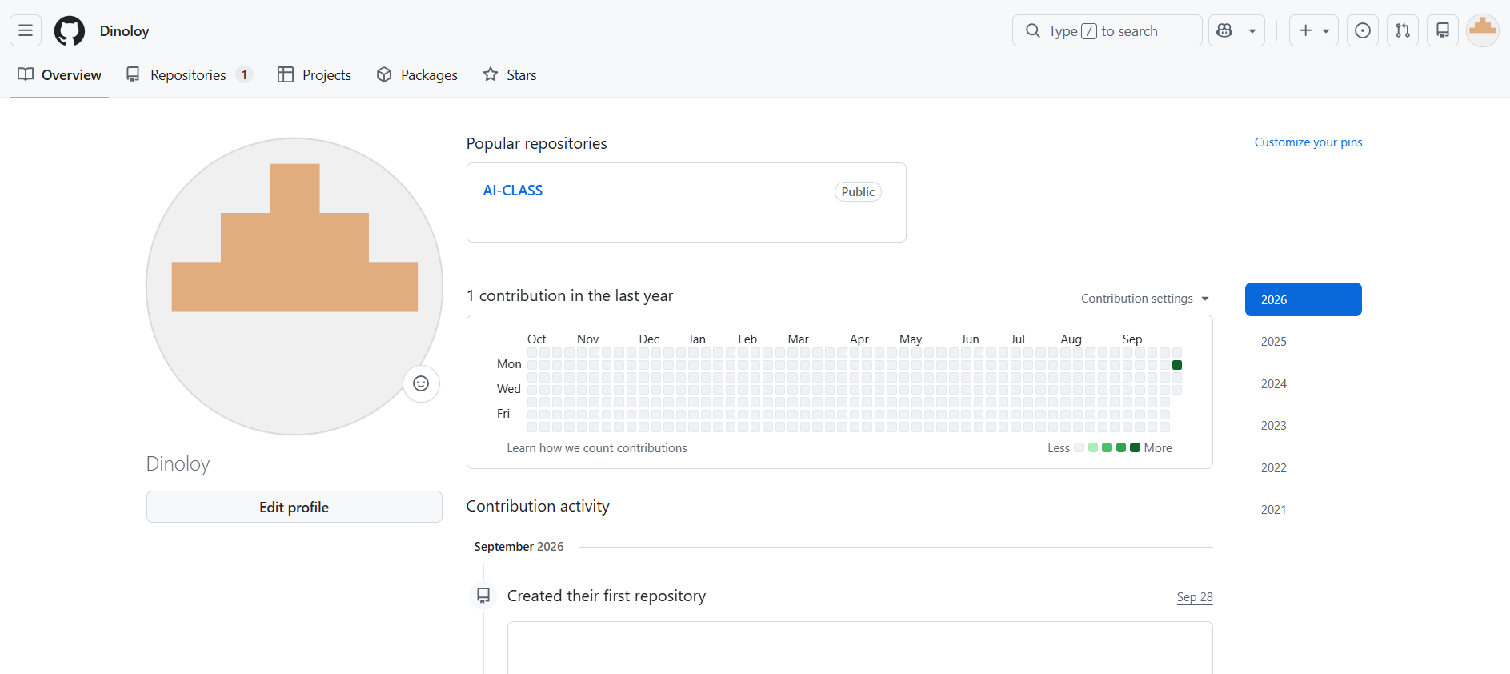

- GitHub installed Copilot is activated
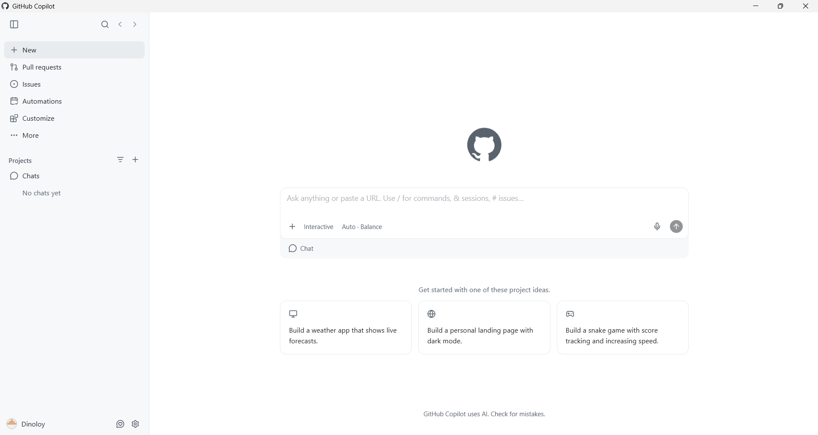
- GitHub Copilot installed in VS code
